Name: THEMBO CHARLES LWANGA

Email: [ashley7520charles@gmail.com](mailto:ashley7520charles@gmail.com)

Contents

Abstract 1

1.1. Acknowledgement 2

1.2. Introduction 2

1.3. Achievements 2

1.3.0. Introduction to bootstrap, CSS, and html 2

1.3.1. Introduction to git 3

1.3.1.1. Connecting to off line repository 3

1.3.1.2. Connection to online repository 4

1.3.2. Comments 5

1.3.3. Conclusion 5

# Abstract

This report overview is about what i learnt in the first week of field work. I cover aspects that have been able to be recalled in the first week session. Well, many words were spoken and aspects explained that i believe will improve on my technology intelligence.

# Acknowledgement

I thank the management of TopBrainz company limited for coming up with such an idea of training technology, which i believe will me a responsible and important person on this planet. I thank you for the promising effort realized in line with technology throughout my field work.

# Introduction

During the first week of field work I understood the basics of HTML, CSS, Bootstrap, Wordpress.com and git. More about these is illustrated and explained in the following sections of this document.

# Achievements

In my first week of industrial training at TopBrainz Company limited, i acquired knowledge about some aspects which involved the overview of what is to be covered. These included mainly Networking, computer hard ware and maintenance, and software development. I learnt how to create repository on github.com using its graphical user interface, that is to say clicking on the link that loads the page for creating the repository, typing the repository name and then submitting. I also realised the easiest way of creating blogs with wordpress.com that will help us to communication effectively.

# Introduction to bootstrap, CSS, and html

I learnt the basics of HTML 5 (Hyper Text Mark-up Language) for web page layout and text display and CSS (Cascading Style Sheet) for styling and painting of the web page. I was introduced to bootstrap which supports display of WebPages the way on all devices including smart phones, tablets, laptops and extra large screen displays. This is done by linking to the bootstrap files and then starting to call the classes and identifiers in the bootstrap page into my HTML page. In this snapshot i placed the CSS bootstrap folder in the same directory as my HTML file.

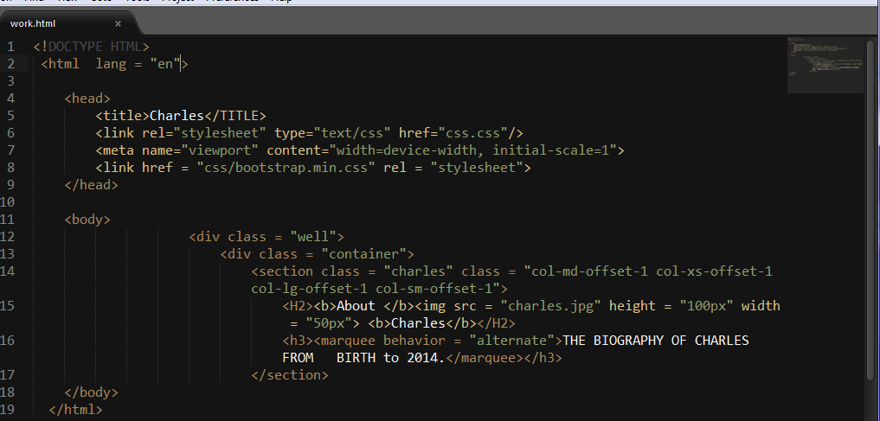

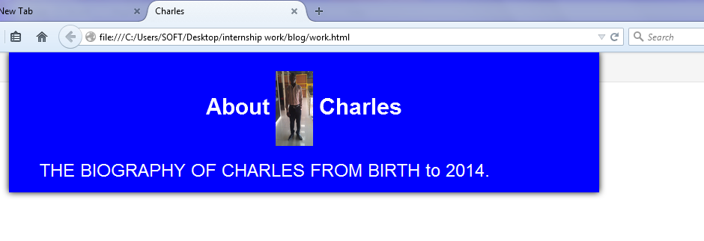

Line 1, <!DOCTYPE HTML> tells the web browser to listen to HTML 5, in line number 2, <html lang = "en">, i select the English language to be used in this webpage. At line 7, <meta name="viewport" content="width=device-width, initial-scale=1"> is where i import the functionality of webpage pagination on all devices, initial-scale=1 means even the smallest device display should be supported. It is at line 8 <link href = "css/bootstrap.min.css" rel = "stylesheet"> that i link to the bootstrap file such that i can call its classes as shown in lines 12, 13 and 14. The blue color comes from my css.css file as shown in the snapshot below.

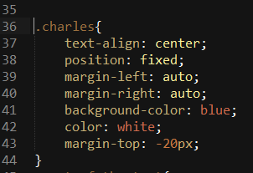

## Introduction to git

## Connecting to off line repository

I also went a bit deep into git as a soft ware, i realised that this software can help me create repository on local host (mainly our computer hard disks) and help me to track the history of my project which is saved in this repository. In the sample snapshots below am using windows Git bush (WINGW32) to illustrate how repository is created on local host.

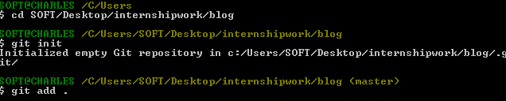This snapshot shows how a repository is created on local host.

The instruction $ git init creates the repository in the specified directory and creates the .git file as shown in the snapshot below.

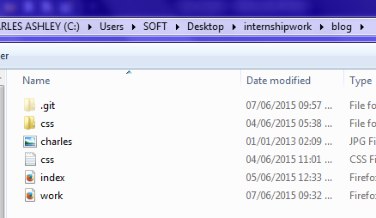

The instruction $ git add . sets all the files in the specified directory to get ready for commission into the repository created. If there is need to add only a single file then i can issue the command $ git add index.html if it the idex.html that i need to commit.

The Instruction git commit –m “description” submits the files in that particular directory int the repository i created.

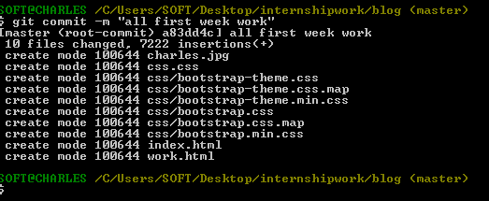

### Connection to online repository

Now, local host storage is susceptible to damage by malicious software like virus and loss of projects in case the computer is stolen. That is why there is need to store our project codes in the cloud. I realised that github.com supports this, and then I created an account with github.com on the link http://github.com/charlesintern, an online repository was also created. To use this repository, i log in to my github.com account and then go back to my git bush while connected to the internet to epush my project to the online repository.

For the first time i need to synchronise to the online repository and the command

$ git remote add origin <http://github.com/charlesintern> connects to my online repository.

To push my file to this repository in use the command

$ git push –u origin master

# Comments

i would like comment about the session room or session environment. I am always inconvenienced with rain and physical noise from the road. Whenever it rains, the room gets wet and some time is wasted as i wait for the room to be moped first before the sessions can continue, this consumes time yet I only have less time (30 days) for this season. If it does not rain, well, only noise can disturb but we always reduce it by closing ourselves inside the room, this does not inconvenience me too much.

# Conclusion

I believe with the help of God and the management of TobBrainz, this period will live me a real man of technology.